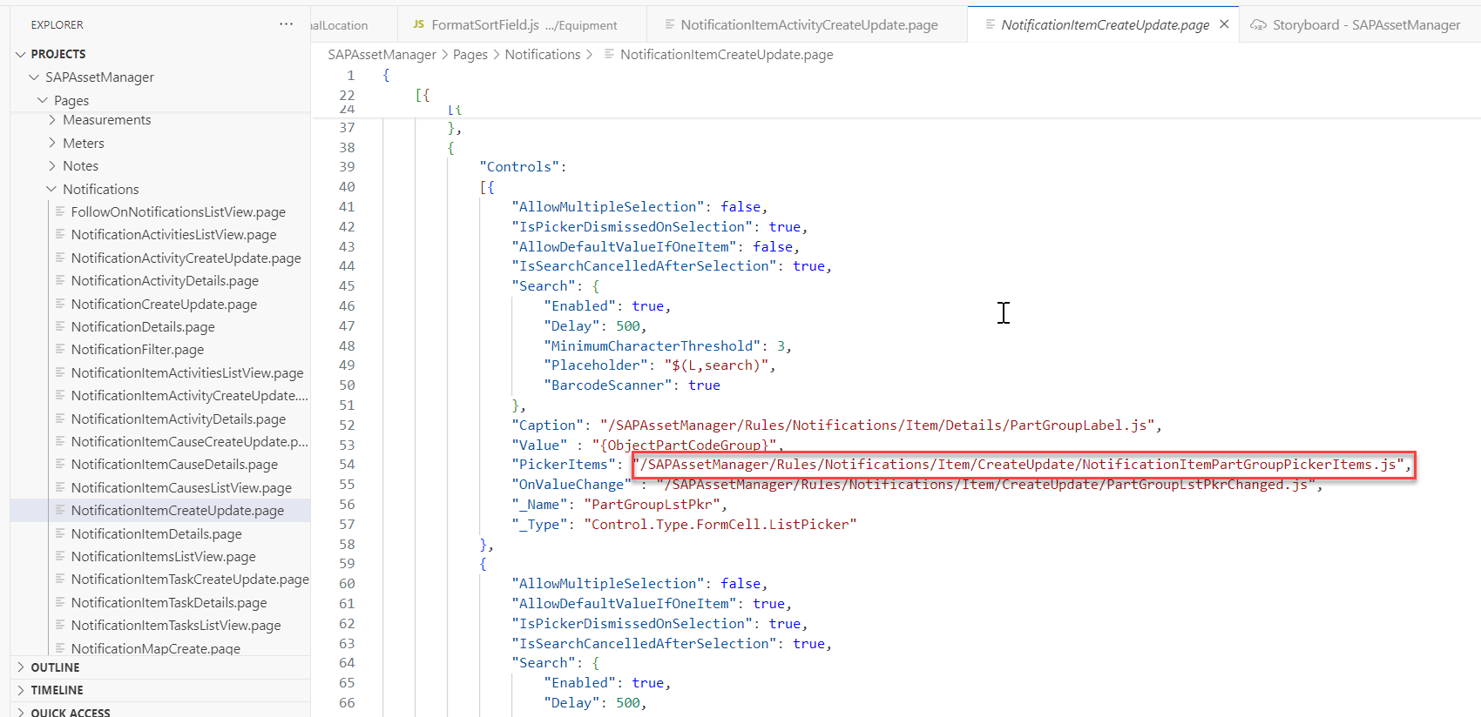

Code:
import libCom from '../../../Common/Library/CommonLibrary';
import ValidationLibrary from '../../../Common/Library/ValidationLibrary';
import NotificationActivityGroupQuery from '../../Activity/NotificationActivityGroupQuery';
import NotificationTaskGroupQuery from '../../Task/NotificationTaskGroupQuery';
import NotificationItemActivityGroupQuery from '../Activity/Details/NotificationItemActivityGroupQuery';
import NotificationItemCauseGroupQuery from '../Cause/NotificationItemCauseGroupQuery';
import NotificationItemDamageGroupQuery from '../NotificationItemDamageGroupQuery';
import NotificationItemPartGroupQuery from '../NotificationItemPartGroupQuery';
import NotificationItemTaskGroupQuery from '../Task/NotificationItemTaskGroupQuery';

/**
* Describe this function...
* @param {IControlProxy} controlProxy
*/
export default function NotificationItemPartGroupPickerItems(controlProxy) {
const pageProxy = controlProxy.getPageProxy();
const { queryOptionsRule, catType } = getOptionsForControl(controlProxy);

return queryOptionsRule(pageProxy).then(queryOptions => {
const isAssignedToCatalogProfile = pageProxy.getClientData()[`IsAssignedToCatalogProfile[${catType}]`];
const usePMCatalogCodes = libCom.isDefined(isAssignedToCatalogProfile) ? !isAssignedToCatalogProfile : false;
let entitySet = 'PMCatalogProfiles';
let displayValue = 'Description';
const returnValue = 'CodeGroup';

if (usePMCatalogCodes) {
entitySet = 'PMCatalogCodes';
displayValue = 'CodeGroupDesc';
}
return pageProxy.read('/SAPAssetManager/Services/AssetManager.service', entitySet, [], queryOptions).then(catalogs => {
if (ValidationLibrary.evalIsEmpty(catalogs)) {
return [];
}
if (usePMCatalogCodes) {
catalogs = [...new Map(catalogs.map(item => [item[returnValue], item])).values()];
}
return Array.from(catalogs, item => ({
ReturnValue: item[returnValue],
DisplayValue: `${item[returnValue]} - ${item[displayValue]}` || '-',
}));
});
});
}

function getOptionsForControl(controlProxy) {
const controlName = controlProxy.getName();
const pageName = libCom.getPageName(controlProxy);
let queryOptionsRule = Promise.resolve();
let catType;

switch (pageName) {
case 'NotificationActivityAddPage':
queryOptionsRule = NotificationActivityGroupQuery;
catType = 'CatTypeActivities';
break;
case 'NotificationItemActivityAddPage':
queryOptionsRule = NotificationItemActivityGroupQuery;
catType = 'CatTypeActivities';
break;
case 'NotificationTaskAddPage':
queryOptionsRule = NotificationTaskGroupQuery;
catType = 'CatTypeTasks';
break;
case 'NotificationItemTaskAddPage':
queryOptionsRule = NotificationItemTaskGroupQuery;
catType = 'CatTypeTasks';
break;
case 'NotificationItemCauseAddPage':
queryOptionsRule = NotificationItemCauseGroupQuery;
catType = 'CatTypeCauses';
break;
case 'NotificationUpdateMalfunctionEnd':
case 'NotificationAddPage':
case 'DefectCreateUpdatePage':
case 'NotificationItemAddPage':
if (controlName === 'PartGroupLstPkr') {
queryOptionsRule = NotificationItemPartGroupQuery;
catType = 'CatTypeObjectParts';
} else if (controlName === 'DamageGroupLstPkr') {
queryOptionsRule = NotificationItemDamageGroupQuery;
catType = 'CatTypeDefects';
} else if (controlName === 'CauseGroupLstPkr') {
queryOptionsRule = NotificationItemCauseGroupQuery;
catType = 'CatTypeCauses';
}
break;
default:
break;
}

return { queryOptionsRule, catType };
}

